PROJECT PLAN

**MISSION STATEMENTS**

***Client Brief – Description (not for site):***

We are a small local company, hoping to improve our business by getting on the net. We get about 100 people playing at Slammers each week. The web site should produce an increase of customers of at least 50%. Volleyball is a great family sport, so we think more young families would enjoy being part of what we offer – volleyball (including professional competitions sometimes), socialising, licensed bar (happy hour every day from 6-7pm), available to hire for functions – fun and fitness.

We get players of all ages, but mostly they are 35 – 50. We want the site to appeal to a younger audience, getting kids playing while they’re in high school (15 – 30). We think more people would play and come and watch competitions if they knew about us more.

**CLIENT MISSION STATEMENT**

**Promote awareness and attendance of Slammers Beach Volleyball as a healthy alternative for fitness among 15 to 30 year olds. Advertise venue hire opportunities and existing social activities**.

**WEBSITE MISSION STATEMENT**

**Gaining a healthy serve of fitness and fun by rallying together with friends and strangers alike. Social competition or that of a world champion, it is your choice, either way shooting for the sky, but aiming for stardom is what VOLLEYBALL has on offer for you.**

Initial planning

Talk to client for clarification

Create file notes

Identify Goals

Client Benefits

Client Brief **Who Can Play**

There are 800 million players worldwide who play volleyball at least once a week. Volleyball is a sport that is safe, fun and does not require extreme fitness. Since you don’t have to move around the court too much, it’s great for people who want a low-impact sport that will help them get fit without pushing them to their limit. For those who are a bit more competitive, the sport is fantastic because games can be really exciting and intense, but there’s always a net between you and your opponents.

Beach volleyball is suitable for people of all ages, and men and women alike.

Anyone considering starting a new sport or exercise program should see their doctor first.

Success Evaluation

Increased revenue

Players

Functions

Positive feedback

Facebook page

Meeting with client

Prior to launch

At launch

One month following launch

Regular meetings and updates (dates to be organised with client)

Target Audience

15 to 30

Content planning

HOME – Main page (index.html)

Overall information

Photos

ABOUT

## About Volleyball

Volleyball is a team sport played by two teams on a playing court divided by a net.

The sport originated in the United States, and is now just achieving the type of popularity in the U.S. that it has received on a global basis, where it ranks behind only soccer among participation sports.

There are 800 million players worldwide who play Volleyball at least once a week.

The object of the game is for each team to send the ball regularly over the net to ground it on the opponent's court, and to prevent the ball from being grounded on its own court. The ball is put into play by the right back-row player who serves the ball by hitting it over the net to the opponent's court. A team is allowed to hit the ball three times (in addition to the block contact) to return it to the opponent's court. A player is not allowed to hit the ball twice consecutively, except when attempting a block. The rally continues until the ball touches the ground/floor, goes "out" or a team fails to return it to the opponent's court or commits a fault.

The team winning a rally scores a point (Rally Point System). When the receiving team wins a rally, it gains a point and the right to serve, and its players rotate one position clockwise.

The best of three or best of five games will win matches. Each non-deciding game will be won by the team that first scores 25 points with a minimum two-point advantage (no scoring cap). If there is a deciding game, it will be won by the team that first scores 15 points with a minimum two-point advantage (no scoring cap).

**Reproduced from http://www.volleyball.org/whatis.html**

VENUE HIRE

SIGN UP

Contact person name

Contact phone number

Contact email address

Competition day choose Monday to Saturday

Tick-box for terms and conditions

## Sign-Up

We would like an online sign-up form so people can register their team on the site.

Data we need would be:

* Contact person name
* Contact phone number
* Contact email address
* Competition day (choose Monday – Saturday)
* Competition time (choose afternoon or evening)
* Tick-box for whether they have read and agree with our playing guidelines (below)

ANNONCEMENTS

## Announcements

During August only, you can purchase 4 drinks for the price of 3 at the bar.

New teams get a 20% discount on registration for the next season.

Slammers Tournament: Get your nominations in now for the next 4-a-side weekend competition.

New season starts August 21st.

PLAYING GUIDELINES

Participants in Slammers Beach Volleyball play at their own risk. Anyone playing is responsible for their own safety and should only play if they are capable. Check with your doctor before you begin.

Game fees must be paid prior to the start of the game. Games may be cancelled by players up to 4 hours before hand to get a refund. Without 4 hours' notice, participants will forfeit the game and be charged 50% of the game fee.

LINKS

Some images require attribution to permit reuse. See <https://creativecommons.org/licenses/by/2.0/>

* <https://www.flickr.com/photos/37873897@N06/5208457834>
* By David Bunting from England - Beach Volleyball Classic 2007, CC BY 2.0, <https://commons.wikimedia.org/w/index.php?curid=3213036>

## Links

http://www.volleyball.org/ - Volleyball worldwide

http://www.fivb.org/EN/beachvolleyball/ - FIVB International Federation of Volleyball, Beach

avp.com – Association of Volleyball Professionals

CONTACT

## Contact

Phone is 47712233

fax: 4771 2244

address: 123 Pokemund Street, Cairsville

email: slammers@ gmail.com

Design and development

Implementation

After launch

Lecture slides slide 5, Week 4, Development and Process Planning

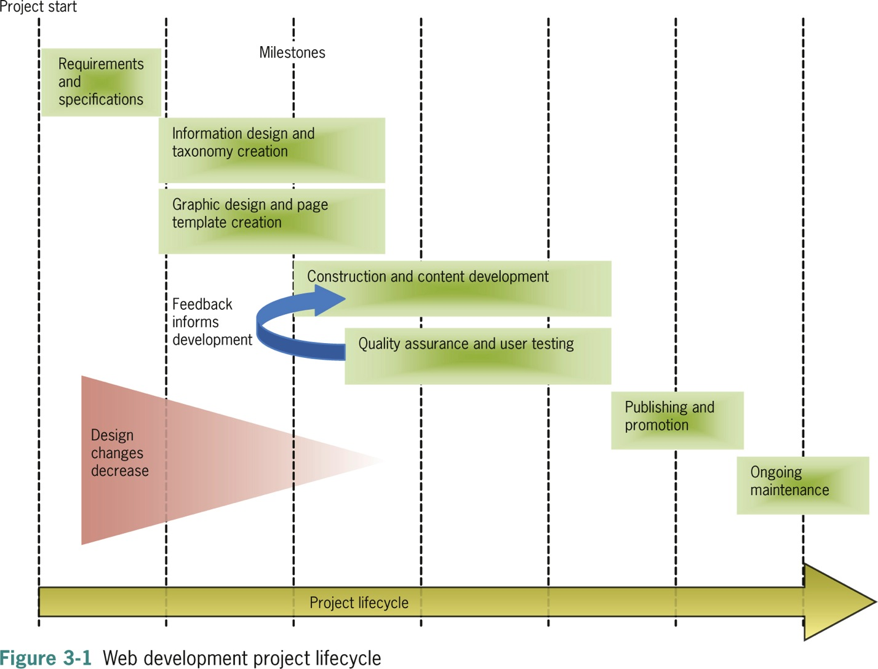

Lecture slides slide 6, Week 4, Development and Process Planning